**R Studio tips and shortcuts**

Last update on 25th July 2022

1. Keyboard Shortcut Quick Reference in RStudio

* R Studio > Tools > Keyboard Shortcuts Help (Alt + Shift + K)

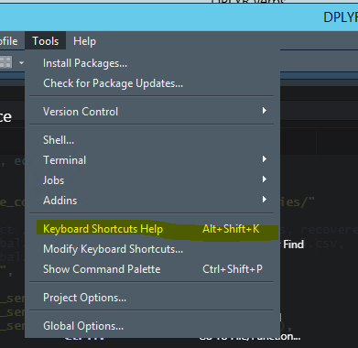

Output

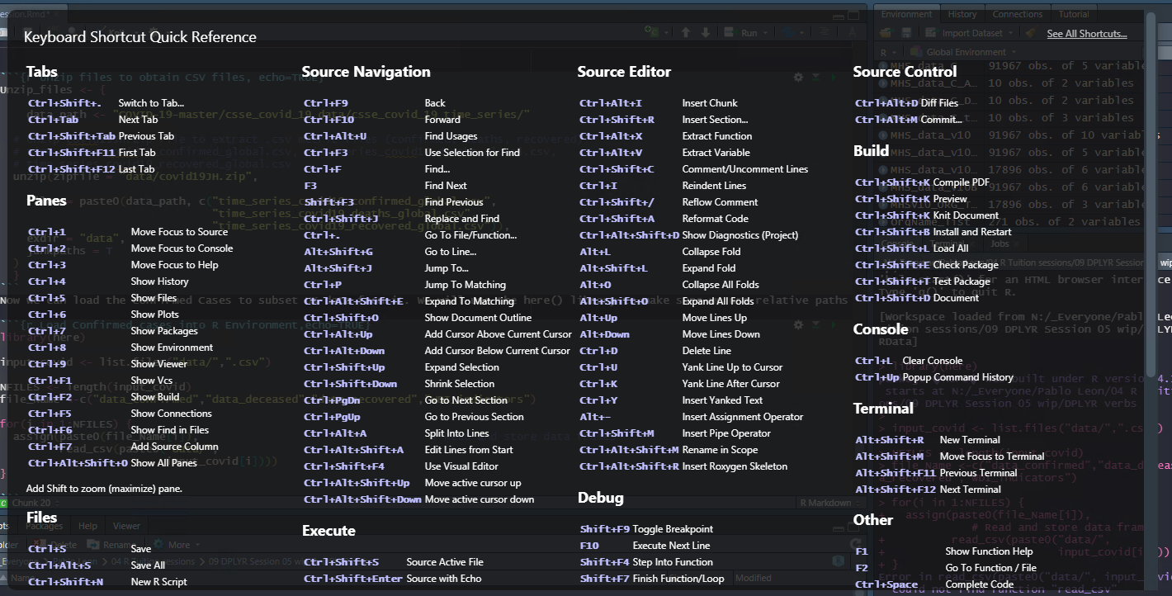

2. This is how you include a new R script chunk when working in R Studio

* Insert R Chunk (Alt + Shift + K)

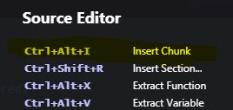

3. Website about general R and R Studio tips and tricks

* 23 RStudio Tips, Tricks, and Shortcuts

<https://www.dataquest.io/blog/rstudio-tips-tricks-shortcuts/#:~:text=Keyboard%20Shortcuts&text=RStudio%20provides%20dozens%20of%20useful,K%20on%20Linux%20and%20Windows>.

4. R Studio Cheat sheet

<https://ucdavis-bioinformatics-training.github.io/Oct2017-ILRI-Workshop/Cheat_Sheets/rstudio-IDE-cheatsheet.pdf>